**Azure Lab 1 – Building the Foundation**

**Description:**  In this first lab of building a core IaaS in Microsoft Azure, you will create the core building blocks for your Azure services:

* Resource Groups
* Storage
* Networking

The services mentioned above are the core pieces that provide a foundation for your applications, virtual machines and hybrid connectivity in Azure. Having this well thought out, provides a great architecture for all of your cloud services.

For each of these steps I have given you the equivalent commands in PowerShell.

|  |  |
| --- | --- |
| Login to the Azure Portal | |
|  | 1. Open a browser and navigate to <http://Portal.Azure.com>. 2. Log in using your Microsoft Azure credentials for your Microsoft Azure subscription. 3. If this is your first time logging into your Azure management portal, close the WINDOWS AZURE TOUR. |

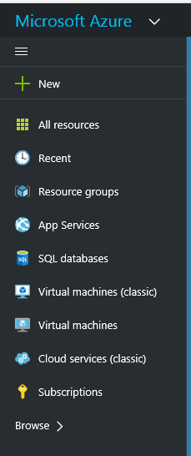***The Azure portal is organized as journeys. A journey is a series of blades, which are containers for the different components. The components within the blades are called parts, which look like tiles.***

|  |  |
| --- | --- |
| Create a Resource Group | |
| Resource groups provide a way to monitor, control access, provision and manage billing for collections of assets that are required to run an application, or used by a client or company department. | 1. Click on Resource Groups to open the Resource Groups blade. 2. Click on the **Add** button. 3. Enter a name for the Resource Group (**WSUG-RG**). 4. Choose the Subscription. 5. Choose a location for the resource group. (**EAST US**). 6. Click Create. |
|  | 1. Click **Refresh** button for your new Resource Group to appear in the blade. |

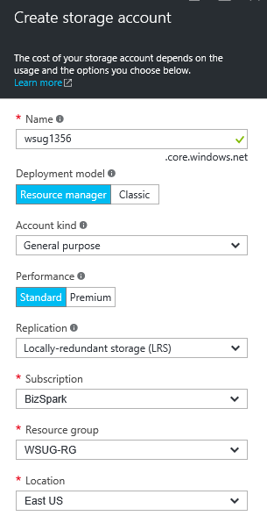

|  |
| --- |
| PowerShell |
| New-AzureRmResourceGroup -Name “WSUG-RG” -Location “EAST US” |

|  |  |
| --- | --- |
| Create a place to store your information | |
|  | 1. On the Resource Groups blade, Click on your resource Group (**WSUG-RG**). 2. On the WSUG-RG resource group blade, Click the **Add** button 3. This will load the “Market Place” |
| Name of the storage account must be unique. **Only accepts numbers and lowercase letters.** | 1. Find and Click on the Storage Account Icon. 2. On the Storage Account Blade, Click the **Create** button. 3. Enter a Name (**wsug1356**). (The name must be unique across all storage accounts in Azure, be between 3 and 24 characters and use numbers and lower-case letters only) |
| Performance  Standard: cheapest  Premium: SSD | 1. Under Performance, Choose **standard**. |
| Replication.  Locally Redundant is cheapest. | 1. Under Replication choose **Locally-redundant storage** (LRS). |
|  | 1. Subscription, Resource group and location should be filled in for us. 2. Click **create** to create your storage account. 3. Close the blades until your back to the market place. |
| PowerShell | |
| *$StorageAccount = New-AzureRmStorageAccount -ResourceGroupName “WSUG-RG” `*  *-Name “*wsug1356*” -Type “Standard_LRS” -Location “East US”* | |

[***https://azure.microsoft.com/en-us/documentation/articles/storage-introduction/***](https://azure.microsoft.com/en-us/documentation/articles/storage-introduction/)

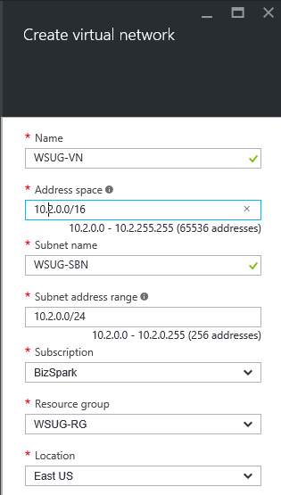

|  |  |
| --- | --- |
| Create a Virtual Network | |
|  | 1. From the market place find and click on the **Virtual network** Icon. 2. On the Virtual network blade, click on **create** button. 3. Enter **WSUG-VN** for Name and **WSUG-SBN** for subnet Name. 4. Click on the **Create** button. 5. Close blades until your back to the market place. |

|  |
| --- |
| PowerShell |
| New-AzureRmResourceGroup -Name “WSUG-RG” -Location “EAST US”  $SubnetConfig = New-AzureRmVirtualNetworkSubnetConfig -Name “WSUG-SBN” `  -AddressPrefix "10.1.0.0/24"  $VNet = New-AzureRmVirtualNetwork -Name “WSUG-VN” `  -ResourceGroupName “WSUG-RG” `  -Location “East US” `  -AddressPrefix "10.1.0.0/16" `  -Subnet $SubnetConfig |
| When running the last PowerShell command above, you may get a warning saying “The output object of this cmdlet will be modified in a future release.” This is normal. |